Elkview Middle Student Info
Welcome Elkview Middle Students! We are looking forward to
working with you and your families make this another
successful school year. There has been a lot of preparation and
planning going in and we’re ready to see each of you!

- August 18th (4:00 – 7:00 p.m.) Open House– ALL EMS Students
and their families are invited to this informal meet and greet time. You’re welcome to come see us anytime from 4:00 – 7:00. Students will be able to meet their teachers, see their classrooms, and learn about our school. Hope to see you there!

- August 22nd First Day for Students
Our day begins at 8:00 each morning. We strongly encourage students to arrive by 7:45. This allows time for you to get
breakfast, go to your locker and to get where you need to be.
If you’re not sure where to go on the first day, just ask a teacher. They will all be in the hallways helping students find their homebase.

”Grab & Go” Breakfast will be available each morning as you enter the building. This can be picked up and eaten in your homebase. If you arrive before 7:30, you will take your breakfast to the cafeteria to eat. After that, you can take it to homebase.
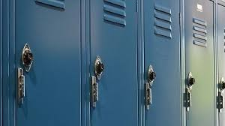
Students will be using lockers this school year. These are assigned in Homebase. Due to the number of students vs. the number of lockers, you will be sharing a locker with another student from your Homebase. Lockers will only be accessible at assigned times throughout the school day.
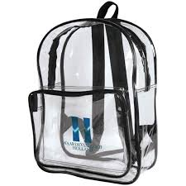
You may find it necessary to carry your belongings in a backpack to and from school. Students must keep their backpacks in their lockers. Our school does not allow backpacks to be carried from class to class. Students participating in Wellness (gym class) can bring their gym clothes and shoes in a small pull string type bag that can be carried to and from Wellness class.

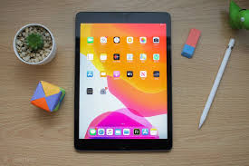
Every student should have issued to them an iPad from Kanawha County Schools. A charged, working iPad is needed EVERY day at Elkview Middle School.

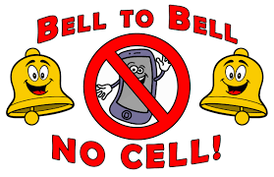
You’re here to learn, not play around on your phone. To help with this, Elkview Middle School follows Kanawha County Schools’ policy that says student cell phone use is prohibited during the school day. If you bring a phone to school, you should keep it in your locker while at school. Please be reminded that neither KCS nor EMS is responsible for lost or stolen electronic devices.

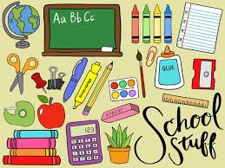
BRING WITH YOU ON THE FIRST DAY: iPad (always bring this fully charged), iPad charger, pen/pencil, and notebook/paper. Teachers will let you know of other items that may be needed or recommended for their classes.

Middle school is a big change from elementary. That being said, our teachers, staff, and administration are all committed to helping every student succeed! We promise to do our part, but we’ll need you to do yours too. To do well in middle school, you need to have good attendance, complete all of your assignments, and become as involved in school activities as you’re able. This is the formula for success and we can’t wait to help you have a great year! See you August 22nd!

